**DS-620 Week 1 Assignment**

Ritesh Kumar B

**From your day-to-day life, take 1 example where visualization plays an important role.**

**Take a picture of the visual / dashboard. Explain in your own words how it helps to solve the purpose and what all possible problems it can solve.**

We may have realized it or not , but Visualization in general has become an undeniable integral part of our daily lives. Companies use it to build strategies and serve their customers better, governments use it for budgeting,spending and tracking progress, while individuals use it to keep track of their spendings, gadget usage and health monitoring. Almost every industry uses visualization in its daily operations.

I personally rely a lot on visualization when it comes to investing. As I am a beginner trader/investor, charts & graphs play a crucial role in successful execution of my trades and to build strategies to make profitable long term investments. For week 1 assignment, we will be using visualized financial information of RELIANCE. The below charts are from “Trading View”, a trading platform that I use to build strategies, stay up to date with the market news and test new styles of trading.

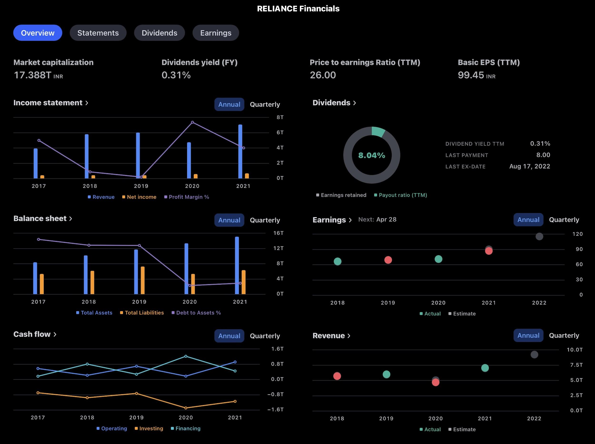

I recently bought 150 shares of Reliance 3 days ago and a bunch of other small cap shares and my portfolio is already up 10.9%. This was possible because of the visualizations I had at hand.

In the first chart (Income Statement), we can see that the Profit margin drastically shot up and their Net Income for 2021 (7 Trillion) crossed an all-time-high(ATH). The first chart already seems to be showing good signs to go ahead and invest.

The second chart (Balance Sheet), which is a combined chart, shows us that Reliance has drastically and successfully been able to reduce its Debt to Assets % from Almost 13 Trillion to merely 3 Trillion only. This is another good sign, which shows that Reliance itself owns most of its Assets and there is very less Debt that they owe. Also, they seem to have increased 1 Trillion worth of their assets.

The third chart (Cash Flow), gives a better understanding of the fundamentals of the company.

Even though their financing was reduced, their operating income and Investments tend to have increased. More Operating Income means the company has been able to keep its costs down and generate revenue. More investing is a sign of chances for more R&D and expansion.

On the other hand, Earnings and Revenue graphs both are forecasting a positive linear trend, which is another good sign to invest in this company.

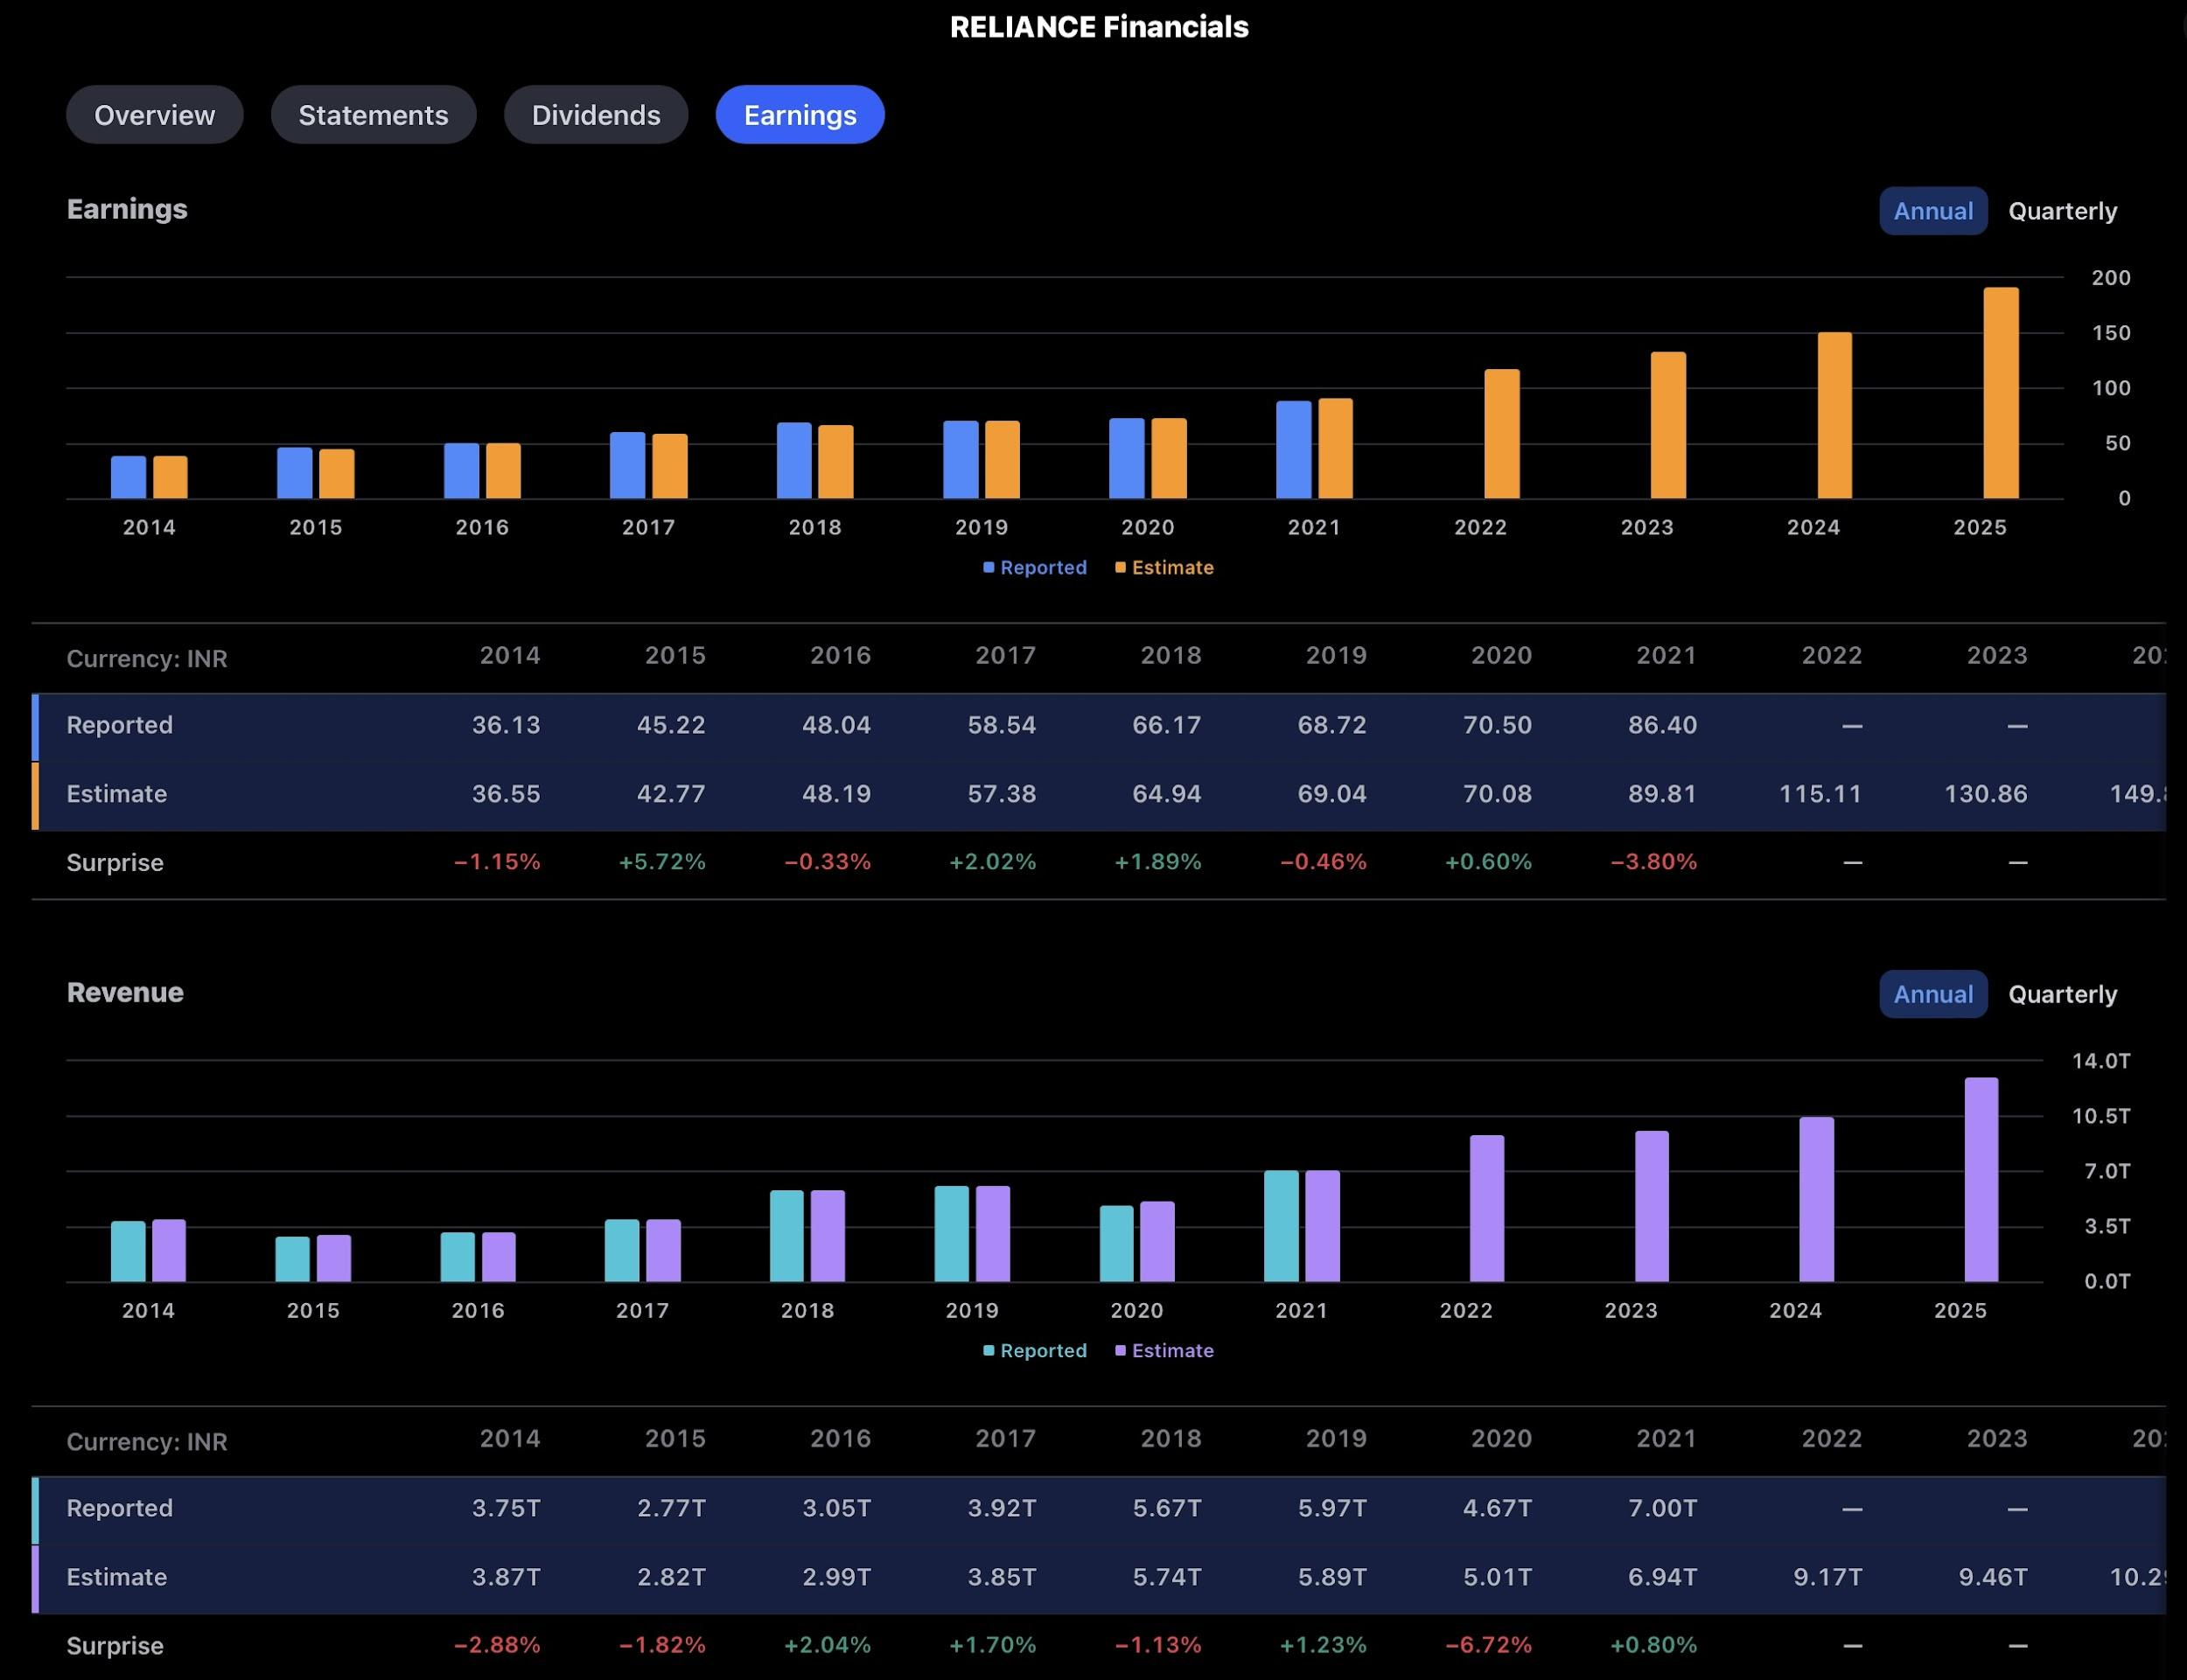

The above figure is from the Earnings section of Reliance, However, both the Earnings & Revenue are forecasting a positive trend, which by many investors / traders is considered to be a good sign to put in their money. The charts show what was Estimated and what was Reported. We can see that there was only a minute difference between Estimated and Reported figures.

All in all, by looking at these above visuals, it gives one a lot of insights about the fundamentals and see what are the areas that the company is suffering or needs to work upon and have an estimate of the risk they may face.